**2.6 Modelo E/R**

**Sugeiri**

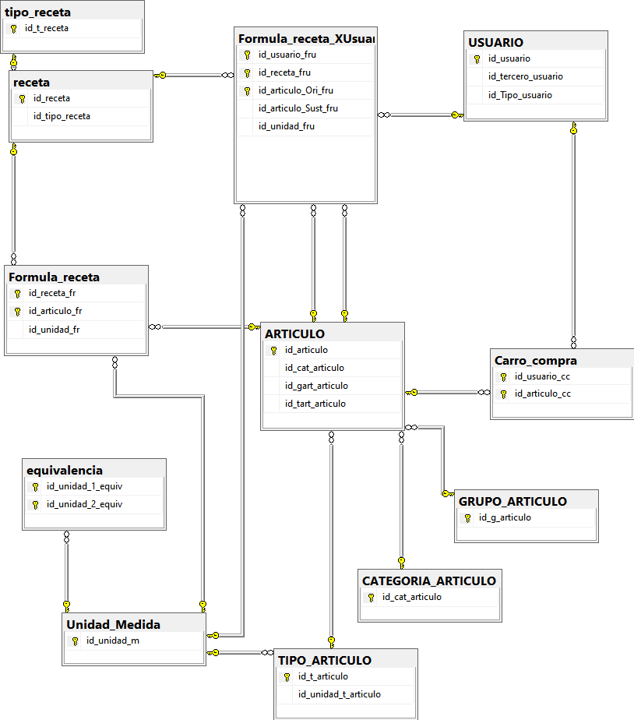

**Basilio**

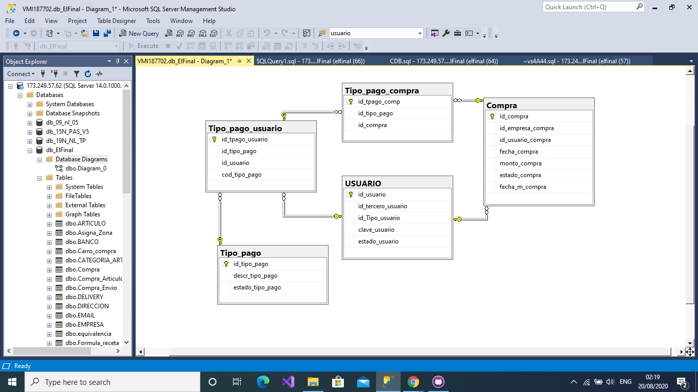

**Luisa**



**Dinnibel**

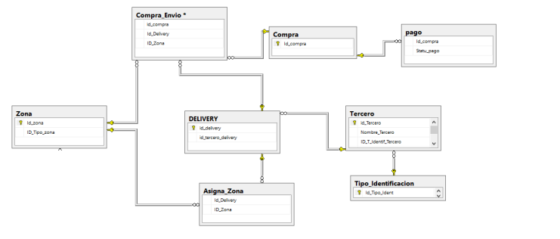

**Enyor Peralta**

